An array is a collection of similar type of elements which has contiguous memory location. Array is index-based, the first element of the array is stored at the 0th index i.e. indexing starts from 0.

There are two types of arrays:

* Single Dimensional Array
* Multidimensional Array

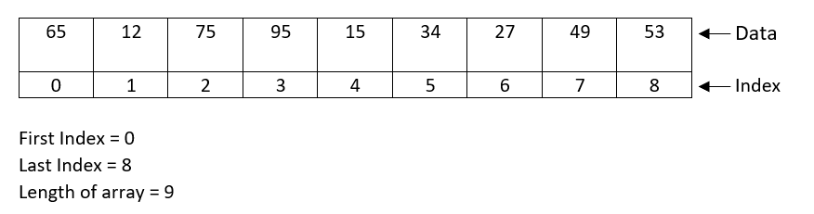

Syntax:

dataType[] arr;

OR

dataType []arr;

OR

dataType arr[];

OR

dataType arrayName = new dataType [size];

OR

dataType arr[] = {data1, data2, data3, ….};

Example1:



Example2:

